5.7 Divergence Theorem Worksheet

- Suppose and is the sphere of radius 2 centered at the origin. Use the Divergence Theorem to calculate the flux of F across .

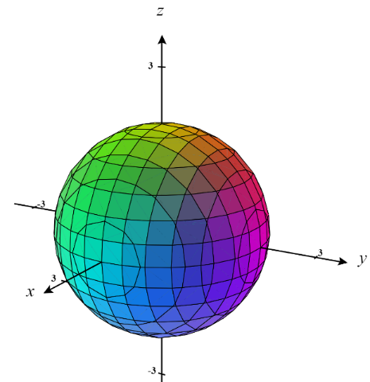
We first note that we have the solid region . The given vector field has components with continuous first partials over G. We will work with assuming it has positive orientation.

So, the Divergence Theorem tells us:
To find the rightmost triple integral, we must employ the techniques of chapter 4. Since we are dealing with a sphere it makes sense to use spherical coordinates.

We see that if then and obviously we let .

So we have that:

- Let . Determine the flux across the surface of the unit cube existing entirely within the first octant with outward orientation.

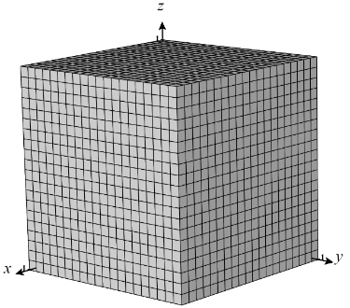
We first note that we have the solid region . The given vector field has components with continuous first partials over G. We will work with assuming it has positive orientation.

So, the Divergence Theorem tells us:
Since the triple integral at the right simply represents the volume of the unit cube we can avoid setting up the triple integral and instead use basic geometry to determine the volume of the unit cube.

So we have that:

- Let and be the surface of the solid bounded above by the paraboloid and below by the plane . Determine the flux across with outward orientation.
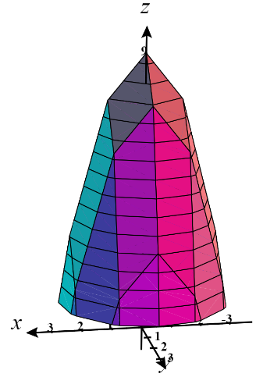
We first note that we have the solid region . The given vector field has components with continuous first partials over G. We will work with assuming it has positive orientation.

So, the Divergence Theorem tells us:

To find the rightmost triple integral, we must employ the techniques of chapter 4.
We see that and consider the projection of the solid to the xy-plane (pictured below). Since this projection is a circle it will be easiest to setup this triple integral using cylindrical coordinates.
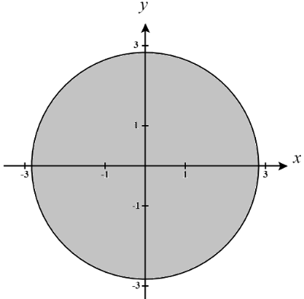
Therefore we express D as
and have

So we have that:
- Let and consider the solid E formed by the following four surfaces:
- : given by where
- : given by
- : given by
- : given by the xy-plane

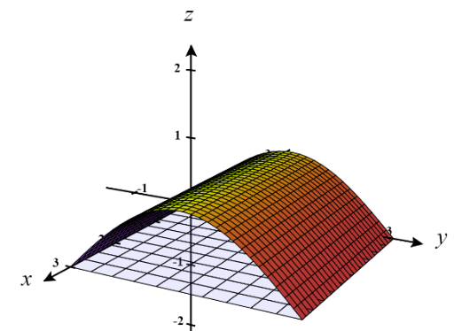
- Determine the flux of F through with respect to inward normals.

We first note that we are working with a solid region E. The given vector field has components with continuous first partials over G. We see that is oriented with inward normals. This is important because it tells us that
So, the Divergence Theorem tells us:

To find the rightmost triple integral, we must employ the techniques of chapter 4.
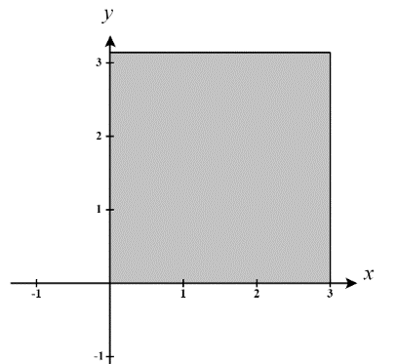
We see that and consider the projection of the solid to the xy-plane (pictured below). We express D as .

So we have that:

- The solid E was made from four surfaces as stated above. The flux of F through exactly two of , , and is exactly 0. Determine which of these corresponds to a nonzero flux.

We can quickly observe that the normal vectors to &would all be parallel to the x-axis and would therefore have the following formfor some value a. However, this implies that and therefore the flow of the fluid will be completely perpendicular to the normal vectors on these sides which results in no fluid flowing out of the solid from these sides.
Therefore, we conclude, that is the side with nonzero flux.

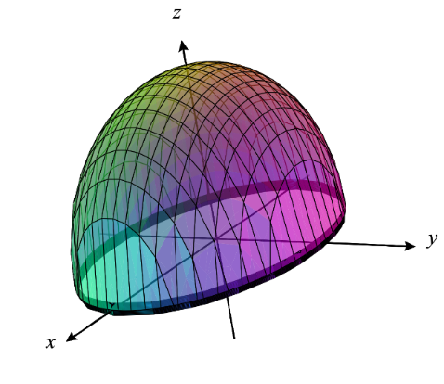
- Set up, but do not evaluate, a triple integral which represents the flux of F across where and is the surface of the solid within the elliptical cylinder bounded above by the ellipsoid and bounded below by the plane with outward orientation.

We assume that has positive orientation. We seek .
Note: that is the boundary of the solid region of .

So, the Divergence Theorem tells us:
We plan to approach this question using cylindrical coordinates. We know that the bounds on z are .
We then project G to the xy-plane to obtain the region.
If we let and , then D is transformed into the region .
A picture of this transformation is shown below:

Our change in variables implies that we are working with the transformation . We then calculate that the Jacobian of our transformation is:
.

Therefore, we can say that:
.
We then see that since S is a unit circle we can be more easily approached the remaining double integral using polar coordinates so we express this region as .
Therefore, we obtain

- Suppose G is a simple solid region in and let be the boundary surface of G, given with positive orientation. Suppose you are told G has a volume of 10. If an object of constant density occupies the region G, then prove that where is the x-coordinate of the center of mass of the solid.

Suppose that the density function for the object is .
By definition, of mass and the fact that G has a volume of 10, we know that:
.

By definition of center of mass, we have that:

Finally, by the Divergence Theorem, we know that: .

